<Recoder>
Software Requirement Specification Document(SRS)
Version <1.0>

2024.05.30

팀장 | 김명준
팀원 | 김남규, 윤형식, 이동현, 전경섭, 조서윤
제출자 | 조서윤

Revision History
Date | Version | Description | Author
<24/04/12> | <1.0> | 초안 | 김명준
<24/04/13> | <1.0> | 기한 수정 및 오타 수정 | 김명준
<24/05/01> | <1.0> | 주제 수정 및 개발 환경 변경 | 김명준
<24/05/12> | <1.0> | 기능 수정 및 엔티티 관계 추가 | 윤형식
<24/05/21> | <1.0> | 테이블 및 간트차트 추가 | 윤형식
<24/05/25> | <1.0> | 문서 수정 | 윤형식
<24/05/30> | <1.0> | 본인 업무 내용 및 코드 추가 | 조서윤

Table of Contents

서론

1-1 Introduction
1-2 Purpose
1-3 Scope
1-4 Overview

본론

2-1 Development Environment
2-2 Term
2-3 Role
2-4 Subsystems
2-5 Entity
2-6 Table

결론

3-1 Code Review
3-1-1 Xml Code
3-1-2 Java Code

3-2 Drawable
3-2-1 Image
3-2-2 Music

Integration Develop Plan

서론

1-1 Introduction

유한대학교 모바일 프로젝트 HGCQ팀이 제작한 추억을 쉽게 회상하도록 도와주는 공유 포토북 앱 Recoder입니다. 자신의 계정으로 로그인하여 날짜별 이벤트를 생성하고, 각 이벤트마다 사진과 간단한 설명을 추가할 수 있습니다. 또한 친구 추가 기능으로 상대방과 친구를 맺을 수 있고 이벤트에 친구를 초대하여 이벤트를 공유할 수 있습니다.

1-2 Purpose

추억을 시간 순으로 정리하고 추억마다의 사진을 분류하여 회상하기 쉽게 합니다.

1-3 Scope

추억을 남들과 공유하고 정리하고 싶은 사람을 대상으로 합니다.

1-4 Overview

친구, 연인 또는 가족끼리 추억을 회상하는 추억 공유 앨범 앱입니다.
특정 사람들과 어떤 이벤트가 있었는지 시간 순으로 볼 수 있습니다.
이벤트마다 공유 앨범으로 친구와 사진을 쉽게 공유할 수 있습니다.

본론
2-1 Development

Front : Android
Backend : Spring Boot
Version and Issue Control : Git, Github
Team Collaboration Tool : Notion

2-2 Term

전체 개발 기간: 2024.04.30 ~ 2024.06.03
UI 구현: 2024.04.30 ~ 2024.05.28
기능 구현: 2024.04.30 ~ 2024.06.03
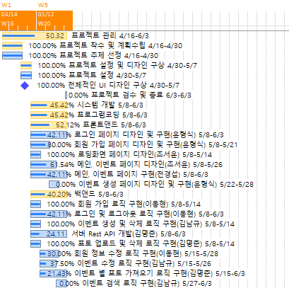

2-3 Role

조서윤 – 전체 UI 디자인, PPT
이벤트, 메인, 로딩화면, 이벤트 생성 페이지 레이아웃 및 로딩화면 액티비티 기능 구현
윤형식 – 문서 작업
로그인, 회원 가입 페이지 레이아웃 및 로그인, 회원가입, 이벤트 생성 액티비티 기능 구현
김명준 – 서버 백엔드
사진 업로드, 사진 삭제, 이벤트 별 사진 리스트 비즈니스 로직 구현 및
서버와 HTTP 통신 API 구현
김남규 – 일정 관리
이벤트 생성, 삭제, 조회, 이벤트에 친구 초대, 이벤트 별 친구 리스트 비즈니스 로직 구현 및
서버와 HTTP 통신 API 구현
전경섭 – 이벤트, 메인 액티비티 기능 구현
이동현 – 회원가입, 로그인, 로그아웃, 회원 정보 수정, 친구 추가, 친구리스트
비즈니스 로직구현 및 서버와 HTTP 통신 API 구현

2-4 Subsystems

회원
회원가입 기능
로그인 기능
로그아웃 기능
회원 정보 수정 기능
이벤트
이벤트 추가 기능
이벤트 삭제 기능
이벤트 검색 기능
이벤트 친구 초대 기능
이벤트 앨범 사진 업로드 기능

2-5 Entity

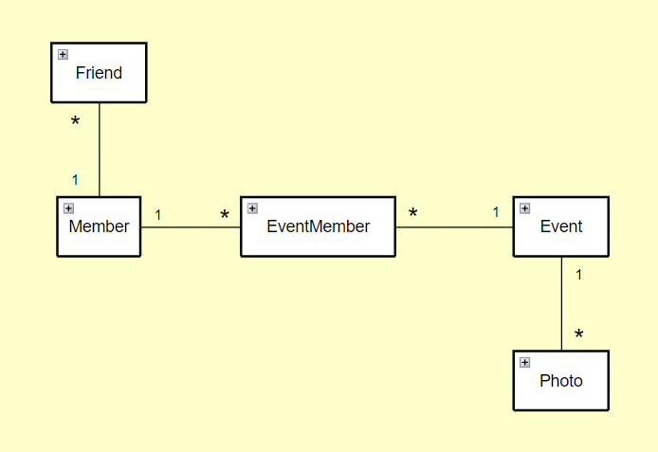
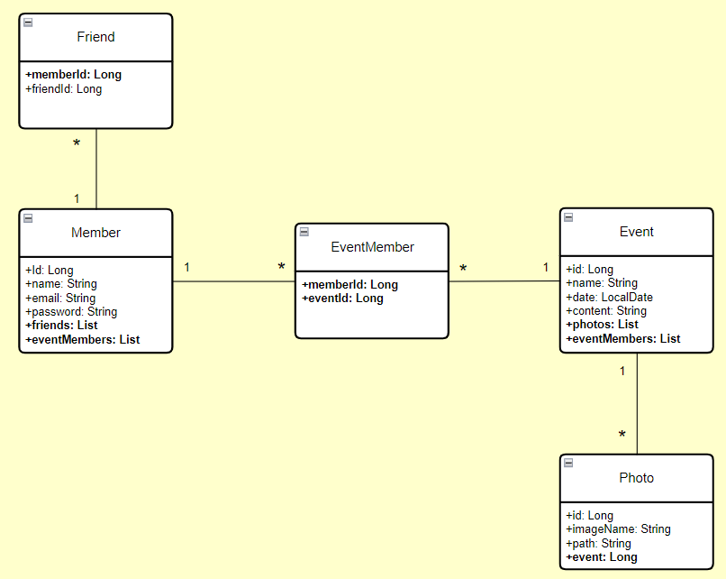
2-6 Table

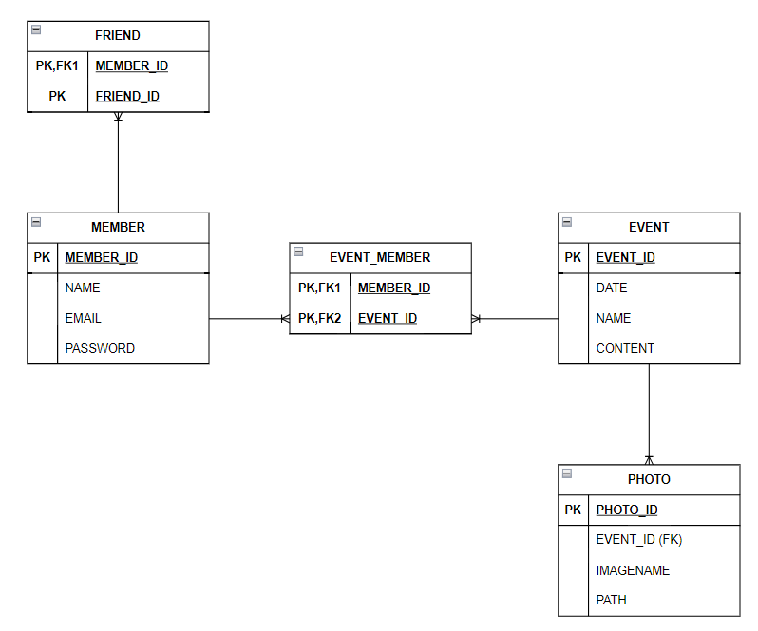

결론
3-1 Code Review – 조서윤
Loading Layout <activity_loading.xml>
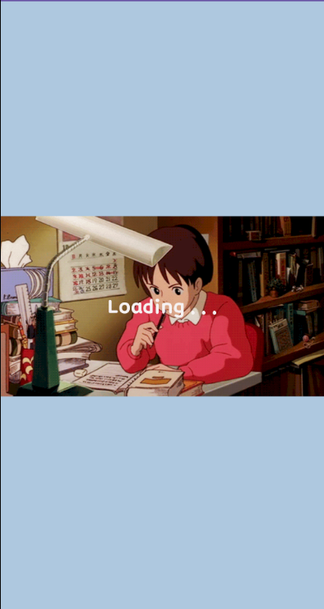

<FrameLayout xmlns:android="http://schemas.android.com/apk/res/android"
xmlns:app="http://schemas.android.com/apk/res-auto"
xmlns:tools="http://schemas.android.com/tools"
android:layout_width="match_parent"
android:layout_height="match_parent"
android:background="#AEC8DF"
tools:context=".activity.Loading">
<ImageView
android:id="@+id/loading"
android:layout_width="425dp"
android:layout_height="218dp"
android:layout_gravity="center"
android:background="#AEC8DF"
app:srcCompat="@drawable/loading" />
<TextView
android:layout_width="wrap_content"
android:layout_height="wrap_content"
android:layout_gravity="center"
android:text="Loading . . ."
android:fontFamily="@font/font_layout"
android:textColor="#F6F2F2"
android:textSize="24sp" />
</FrameLayout>

Main Layout <activity_main.xml>

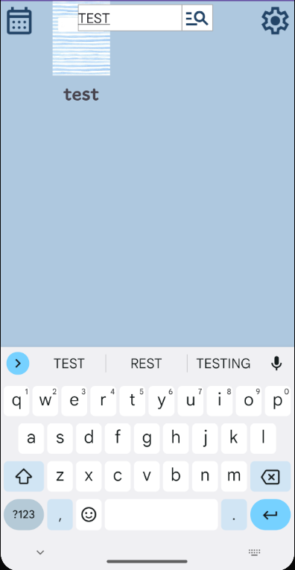

<androidx.constraintlayout.widget.ConstraintLayout xmlns:android="http://schemas.android.com/apk/res/android"
xmlns:app="http://schemas.android.com/apk/res-auto"
xmlns:tools="http://schemas.android.com/tools"
android:id="@+id/main"
android:layout_width="match_parent"
android:layout_height="match_parent"
android:background="#AEC8DF"
tools:context=".activity.Main">
<androidx.recyclerview.widget.RecyclerView
android:id="@+id/eventList"
android:layout_width="match_parent"
android:layout_height="624dp"
android:gravity="center"
android:padding="17dp"
app:layoutManager="androidx.recyclerview.widget.GridLayoutManager"
app:layout_constraintBottom_toBottomOf="parent"
app:layout_constraintEnd_toEndOf="parent"
app:layout_constraintTop_toTopOf="parent"
app:layout_constraintVertical_bias="0.523"
app:spanCount="2" />
<EditText
android:id="@+id/searchText"
android:layout_width="144dp"
android:layout_height="36dp"
android:layout_marginTop="4dp"
android:background="@drawable/border"
android:fontFamily="@font/font_layout"
android:textColor="#000"
app:layout_constraintEnd_toEndOf="parent"
app:layout_constraintHorizontal_bias="0.416"
app:layout_constraintStart_toStartOf="parent"
app:layout_constraintTop_toTopOf="parent" />
<ImageButton
android:id="@+id/plus"
android:layout_width="48dp"
android:layout_height="47dp"
android:layout_marginTop="680dp"
android:background="#00000000"
android:scaleType="fitCenter"
android:src="@drawable/plusicon"
app:layout_constraintEnd_toEndOf="parent"
app:layout_constraintHorizontal_bias="0.523"
app:layout_constraintStart_toStartOf="parent"
app:layout_constraintTop_toTopOf="parent"
app:tint="#234567" />
<ImageButton
android:id="@+id/search"
android:layout_width="42dp"
android:layout_height="36dp"
android:layout_marginTop="4dp"
android:background="@drawable/border"
android:scaleType="fitCenter"
android:src="@drawable/search"
app:layout_constraintEnd_toEndOf="parent"
app:layout_constraintHorizontal_bias="0.691"
app:layout_constraintStart_toStartOf="parent"
app:layout_constraintTop_toTopOf="parent"
app:tint="#234567" />
<ImageButton
android:id="@+id/date"
android:layout_width="50dp"
android:layout_height="44dp"
android:layout_marginTop="4dp"
android:background="#00000000"
android:backgroundTint="#C4D0DC"
android:scaleType="fitCenter"
android:src="@drawable/calendar"
app:layout_constraintEnd_toEndOf="parent"
app:layout_constraintHorizontal_bias="0.0"
app:layout_constraintStart_toStartOf="parent"
app:layout_constraintTop_toTopOf="parent"
app:tint="#234567" />
<ImageButton
android:id="@+id/set"
android:layout_width="50dp"
android:layout_height="44dp"
android:layout_marginTop="4dp"
android:background="#00000000"
android:scaleType="fitCenter"
android:src="@drawable/seticon"
app:layout_constraintEnd_toEndOf="parent"
app:layout_constraintHorizontal_bias="1.0"
app:layout_constraintStart_toStartOf="parent"
app:layout_constraintTop_toTopOf="parent"
app:tint="#234567" />
<androidx.recyclerview.widget.RecyclerView
android:id="@+id/settingList"
android:layout_width="50dp"
android:layout_height="150dp"
android:background="#FFFFFF"
android:clipToPadding="false"
android:elevation="4dp"
android:scrollbars="vertical"
android:visibility="gone"
app:layout_constraintBottom_toBottomOf="parent"
app:layout_constraintEnd_toEndOf="parent"
app:layout_constraintTop_toTopOf="parent"
app:layout_constraintVertical_bias="0.09" />
<ImageButton
android:id="@+id/logout"
android:layout_width="40dp"
android:layout_height="40dp"
android:layout_marginEnd="8dp"
android:background="#00000000"
android:elevation="5dp"
android:scaleType="fitCenter"
android:src="@drawable/exit"
android:tint="#234567"
android:visibility="gone"
app:layout_constraintBottom_toBottomOf="parent"
app:layout_constraintEnd_toEndOf="parent"
app:layout_constraintTop_toTopOf="parent"
app:layout_constraintVertical_bias="0.225" />
<ImageButton
android:id="@+id/modify"
android:layout_width="40dp"
android:layout_height="40dp"
android:layout_marginEnd="8dp"
android:background="#00000000"
android:elevation="5dp"
android:scaleType="fitCenter"
android:src="@drawable/modify"
android:tint="#234567"
android:visibility="gone"
app:layout_constraintBottom_toBottomOf="parent"
app:layout_constraintEnd_toEndOf="parent"
app:layout_constraintTop_toTopOf="parent"
app:layout_constraintVertical_bias="0.153" />
<ImageButton
android:id="@+id/friend"
android:layout_width="40dp"
android:layout_height="40dp"
android:layout_marginEnd="8dp"
android:background="#00000000"
android:elevation="5dp"
android:scaleType="fitCenter"
android:src="@drawable/friend"
android:tint="#234567"
android:visibility="gone"
app:layout_constraintBottom_toBottomOf="parent"
app:layout_constraintEnd_toEndOf="parent"
app:layout_constraintTop_toTopOf="parent"
app:layout_constraintVertical_bias="0.081" />
</androidx.constraintlayout.widget.ConstraintLayout>

Event Layout <activity_event.xml>
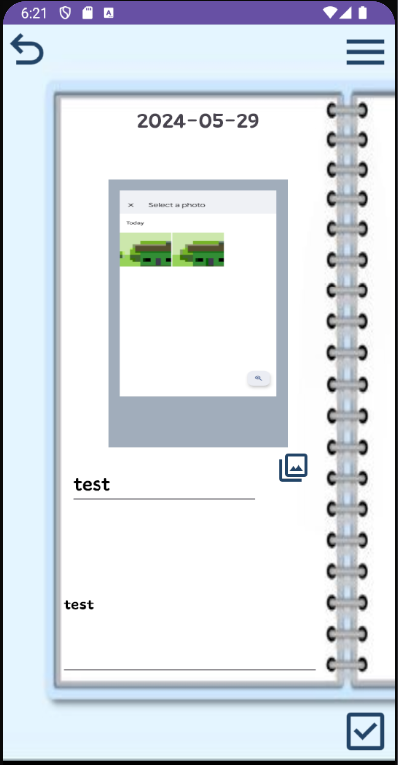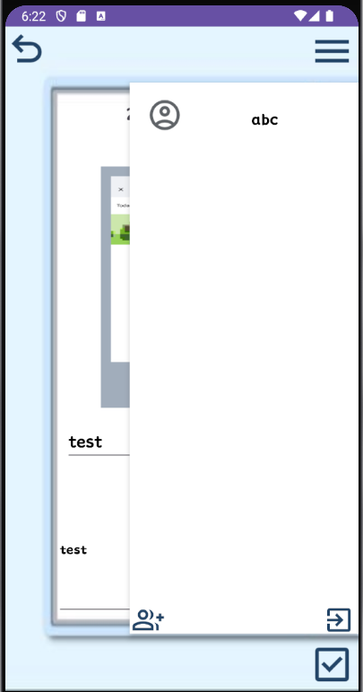

<androidx.constraintlayout.widget.ConstraintLayout xmlns:android="http://schemas.android.com/apk/res/android"
xmlns:app="http://schemas.android.com/apk/res-auto"
xmlns:tools="http://schemas.android.com/tools"
android:id="@+id/main"
android:layout_width="match_parent"
android:layout_height="match_parent"
android:background="@drawable/diary"
tools:context=".activity.Event">
<EditText
android:id="@+id/content"
android:layout_width="261dp"
android:layout_height="148dp"
android:layout_marginBottom="28dp"
android:fontFamily="@font/font_layout"
android:hint="내용을 입력하세요."
android:textColor="#000000"
android:textSize="14sp"
app:layout_constraintBottom_toTopOf="@id/save"
app:layout_constraintEnd_toEndOf="parent"
app:layout_constraintHorizontal_bias="0.433"
app:layout_constraintStart_toStartOf="parent" />
<ImageView
android:id="@+id/background"
android:layout_width="226dp"
android:layout_height="268dp"
android:layout_marginBottom="84dp"
app:layout_constraintBottom_toTopOf="@id/content"
app:layout_constraintEnd_toEndOf="parent"
app:layout_constraintHorizontal_bias="0.497"
app:layout_constraintStart_toStartOf="parent"
app:srcCompat="@drawable/post" />
<ImageButton
android:id="@+id/addPhoto"
android:layout_width="35dp"
android:layout_height="35dp"
android:layout_marginEnd="84dp"
android:layout_marginBottom="276dp"
android:background="#00000000"
android:scaleType="fitCenter"
android:src="@drawable/photolibraryicon"
app:layout_constraintBottom_toBottomOf="parent"
app:layout_constraintEnd_toEndOf="parent"
app:tint="#234567" />
<ImageButton
android:id="@+id/save"
android:layout_width="50dp"
android:layout_height="50dp"
android:layout_marginEnd="4dp"
android:layout_marginBottom="4dp"
android:background="#00000000"
android:scaleType="fitCenter"
android:src="@drawable/saveicon"
app:layout_constraintBottom_toBottomOf="parent"
app:layout_constraintEnd_toEndOf="parent"
app:tint="#234567" />
<ImageButton
android:id="@+id/back"
android:layout_width="50dp"
android:layout_height="50dp"
android:layout_marginEnd="344dp"
android:layout_marginBottom="688dp"
android:background="#00000000"
android:scaleType="fitCenter"
android:src="@drawable/backicon"
app:layout_constraintBottom_toBottomOf="parent"
app:layout_constraintEnd_toEndOf="parent"
app:layout_constraintTop_toTopOf="parent"
app:layout_constraintVertical_bias="0.0"
app:tint="#234567" />
<ImageButton
android:id="@+id/setting"
android:layout_width="50dp"
android:layout_height="50dp"
android:layout_marginEnd="4dp"
android:background="#00000000"
android:scaleType="fitCenter"
android:src="@drawable/menuicon"
app:layout_constraintBottom_toBottomOf="parent"
app:layout_constraintEnd_toEndOf="parent"
app:layout_constraintTop_toTopOf="parent"
app:layout_constraintVertical_bias="0.003"
app:tint="#234567" />
<TextView
android:id="@+id/date"
android:layout_width="wrap_content"
android:layout_height="wrap_content"
android:layout_marginEnd="136dp"
android:fontFamily="@font/font_layout"
android:text="2000-00-00"
android:textSize="20sp"
app:layout_constraintBottom_toBottomOf="parent"
app:layout_constraintEnd_toEndOf="parent"
app:layout_constraintTop_toTopOf="parent"
app:layout_constraintVertical_bias="0.116" />
<EditText
android:id="@+id/title"
android:layout_width="190dp"
android:layout_height="wrap_content"
android:layout_marginEnd="136dp"
android:fontFamily="@font/font_layout"
android:ems="10"
android:inputType="text"
android:textColor="#000000"
app:layout_constraintBottom_toBottomOf="parent"
app:layout_constraintEnd_toEndOf="parent"
app:layout_constraintTop_toTopOf="parent"
app:layout_constraintVertical_bias="0.634" />
<ImageView
android:id="@+id/photo"
android:layout_width="156dp"
android:layout_height="206dp"
android:scaleType="fitXY"
app:layout_constraintBottom_toBottomOf="parent"
app:layout_constraintEnd_toEndOf="parent"
app:layout_constraintHorizontal_bias="0.498"
app:layout_constraintStart_toStartOf="parent"
app:layout_constraintTop_toTopOf="parent"
app:layout_constraintVertical_bias="0.313" />

<androidx.recyclerview.widget.RecyclerView
android:id="@+id/settingList"
android:layout_width="254dp"
android:layout_height="612dp"
android:background="#FFFFFF"
android:clipToPadding="false"
android:elevation="4dp"
android:scrollbars="vertical"
android:visibility="gone"
app:layout_constraintBottom_toBottomOf="parent"
app:layout_constraintEnd_toEndOf="parent"
app:layout_constraintTop_toTopOf="parent"
app:layout_constraintVertical_bias="0.495" />
<androidx.recyclerview.widget.RecyclerView
android:id="@+id/friendList"
android:layout_width="174dp"
android:layout_height="612dp"
android:layout_marginEnd="116dp"
android:background="#FFFFFF"
android:clipToPadding="false"
android:elevation="6dp"
android:scrollbars="vertical"
android:visibility="gone"
app:layout_constraintBottom_toBottomOf="parent"
app:layout_constraintEnd_toEndOf="parent"
app:layout_constraintTop_toTopOf="parent"
app:layout_constraintVertical_bias="0.546" />
<ImageButton
android:id="@+id/add"
android:layout_width="35dp"
android:layout_height="35dp"
android:layout_marginEnd="216dp"
android:background="#00000000"
android:elevation="5dp"
android:scaleType="fitCenter"
android:src="@drawable/friendadd"
android:visibility="gone"
app:layout_constraintBottom_toBottomOf="parent"
app:layout_constraintEnd_toEndOf="parent"
app:layout_constraintTop_toTopOf="parent"
app:layout_constraintVertical_bias="0.913"
app:tint="#234567" />
<ImageButton
android:id="@+id/exit"
android:layout_width="35dp"
android:layout_height="35dp"
android:layout_marginEnd="4dp"
android:background="#00000000"
android:elevation="5dp"
android:scaleType="fitCenter"
android:src="@drawable/exit"
android:visibility="gone"
app:layout_constraintBottom_toBottomOf="parent"
app:layout_constraintEnd_toEndOf="parent"
app:layout_constraintTop_toTopOf="parent"
app:layout_constraintVertical_bias="0.913"
app:tint="#234567" />
</androidx.constraintlayout.widget.ConstraintLayout>
EventCreate Layout <activity_eventCreate.xml>
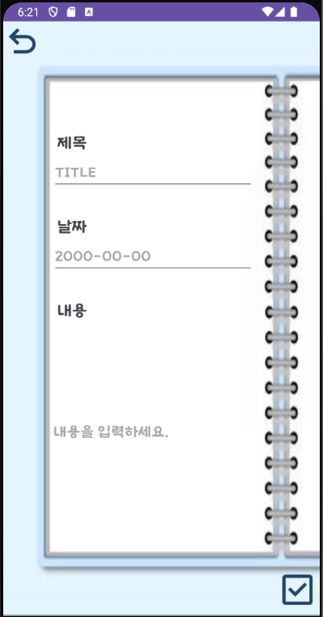

<androidx.constraintlayout.widget.ConstraintLayout xmlns:android="http://schemas.android.com/apk/res/android"
xmlns:app="http://schemas.android.com/apk/res-auto"
xmlns:tools="http://schemas.android.com/tools"
android:id="@+id/main"
android:layout_width="match_parent"
android:layout_height="match_parent"
android:background="@drawable/diary"
tools:context=".activity.Main">
<ScrollView
android:layout_width="match_parent"
android:layout_height="match_parent">
<androidx.constraintlayout.widget.ConstraintLayout
android:layout_width="match_parent"
android:layout_height="wrap_content">
<ImageButton
android:id="@+id/back"
android:layout_width="50dp"
android:layout_height="50dp"
android:layout_marginEnd="344dp"
android:layout_marginBottom="688dp"
android:background="#00000000"
android:scaleType="fitCenter"
android:src="@drawable/backicon"
app:layout_constraintBottom_toBottomOf="parent"
app:layout_constraintEnd_toEndOf="parent"
app:layout_constraintTop_toTopOf="parent"
app:layout_constraintVertical_bias="1.0"
app:tint="#234567" />
<TextView
android:id="@+id/date_text"
android:layout_width="wrap_content"
android:layout_height="wrap_content"
android:layout_marginTop="240dp"
android:fontFamily="@font/font_layout"
android:text="날짜"
android:textSize="20sp"
app:layout_constraintEnd_toEndOf="parent"
app:layout_constraintHorizontal_bias="0.189"
app:layout_constraintStart_toStartOf="parent"
app:layout_constraintTop_toTopOf="parent" />
<EditText
android:id="@+id/date"
android:layout_width="wrap_content"
android:layout_height="wrap_content"
android:layout_marginTop="268dp"
android:ems="10"
android:fontFamily="@font/font_layout"
android:hint="2000-00-00"
android:inputType="date"
android:textColor="#000000"
app:layout_constraintEnd_toEndOf="parent"
app:layout_constraintHorizontal_bias="0.429"
app:layout_constraintStart_toStartOf="parent"
app:layout_constraintTop_toTopOf="parent" />
<TextView
android:id="@+id/title_text"
android:layout_width="wrap_content"
android:layout_height="wrap_content"
android:layout_marginTop="136dp"
android:fontFamily="@font/font_layout"
android:text="제목"
android:textSize="20sp"
app:layout_constraintEnd_toEndOf="parent"
app:layout_constraintHorizontal_bias="0.189"
app:layout_constraintStart_toStartOf="parent"
app:layout_constraintTop_toTopOf="parent" />
<EditText
android:id="@+id/title"
android:layout_width="wrap_content"
android:layout_height="wrap_content"
android:layout_marginTop="164dp"
android:ems="10"
android:fontFamily="@font/font_layout"
android:hint="TITLE"
android:inputType="textPersonName"
android:textColor="#000000"
app:layout_constraintEnd_toEndOf="parent"
app:layout_constraintHorizontal_bias="0.429"
app:layout_constraintStart_toStartOf="parent"
app:layout_constraintTop_toTopOf="parent" />
<TextView
android:id="@+id/content_text"
android:layout_width="wrap_content"
android:layout_height="wrap_content"
android:layout_marginTop="344dp"
android:fontFamily="@font/font_layout"
android:text="내용"
android:textSize="20sp"
app:layout_constraintEnd_toEndOf="parent"
app:layout_constraintHorizontal_bias="0.189"
app:layout_constraintStart_toStartOf="parent"
app:layout_constraintTop_toTopOf="parent" />
<EditText
android:id="@+id/content"
android:layout_width="259dp"
android:layout_height="257dp"
android:layout_marginTop="380dp"
android:background="@drawable/edittext_background"
android:ems="10"
android:fontFamily="@font/font_layout"
android:hint="내용을 입력하세요."
android:inputType="textPersonName"
android:textColor="#000000"
app:layout_constraintEnd_toEndOf="parent"
app:layout_constraintHorizontal_bias="0.467"
app:layout_constraintStart_toStartOf="parent"
app:layout_constraintTop_toTopOf="parent" />
<ImageButton
android:id="@+id/save"
android:layout_width="50dp"
android:layout_height="50dp"
android:layout_marginTop="680dp"
android:background="#00000000"
android:scaleType="fitCenter"
android:src="@drawable/saveicon"
app:layout_constraintEnd_toEndOf="parent"
app:layout_constraintHorizontal_bias="0.994"
app:layout_constraintStart_toStartOf="parent"
app:layout_constraintTop_toTopOf="parent"
app:tint="#234567" />
</androidx.constraintlayout.widget.ConstraintLayout>
</ScrollView>
</androidx.constraintlayout.widget.ConstraintLayout>
Modify Layout <activity_modify.xml>
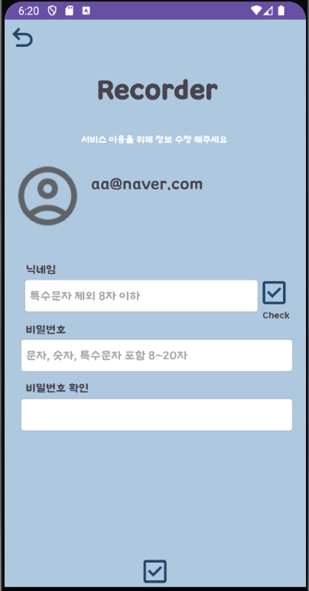

<androidx.constraintlayout.widget.ConstraintLayout xmlns:android="http://schemas.android.com/apk/res/android"
xmlns:app="http://schemas.android.com/apk/res-auto"
xmlns:tools="http://schemas.android.com/tools"
android:id="@+id/main"
android:layout_width="match_parent"
android:layout_height="match_parent"
android:background="#AEC8DF"
tools:context=".activity.Modify">
<ImageView
android:layout_width="113dp"
android:layout_height="92dp"
android:layout_marginEnd="280dp"
android:src="@drawable/profile"
app:layout_constraintBottom_toBottomOf="parent"
app:layout_constraintEnd_toEndOf="parent"
app:layout_constraintTop_toTopOf="parent"
app:layout_constraintVertical_bias="0.284" />
<TextView
android:id="@+id/email"
android:layout_width="268dp"
android:layout_height="86dp"
android:layout_marginEnd="12dp"
android:fontFamily="@font/font_layout"
android:text="email"
android:textSize="20dp"
app:layout_constraintBottom_toBottomOf="parent"
app:layout_constraintEnd_toEndOf="parent"
app:layout_constraintTop_toTopOf="parent"
app:layout_constraintVertical_bias="0.306" />
<TextView
android:layout_width="wrap_content"
android:layout_height="wrap_content"
android:fontFamily="@font/font1"
android:text="서비스 이용을 위해 정보 수정 해주세요"
android:textColor="#FFFFFF"
android:textSize="12sp"
app:layout_constraintBottom_toBottomOf="parent"
app:layout_constraintEnd_toEndOf="parent"
app:layout_constraintHorizontal_bias="0.497"
app:layout_constraintStart_toStartOf="parent"
app:layout_constraintTop_toTopOf="parent"
app:layout_constraintVertical_bias="0.204" />
<ImageButton
android:id="@+id/back"
android:layout_width="40dp"
android:layout_height="40dp"
android:background="#00000000"
android:scaleType="fitCenter"
android:src="@drawable/backicon"
app:layout_constraintBottom_toBottomOf="parent"
app:layout_constraintEnd_toEndOf="parent"
app:layout_constraintHorizontal_bias="0.01"
app:layout_constraintStart_toStartOf="parent"
app:layout_constraintTop_toTopOf="parent"
app:layout_constraintVertical_bias="0.005"
app:tint="#234567" />
<EditText
android:id="@+id/name"
android:layout_width="310dp"
android:layout_height="48dp"
android:background="@android:drawable/editbox_background"
android:fontFamily="@font/font1"
android:hint="특수문자 제외 8자 이하"
android:inputType="text"
android:maxLength="8"
android:textColor="#000000"
android:textSize="15dp"
app:layout_constraintBottom_toBottomOf="parent"
app:layout_constraintEnd_toEndOf="parent"
app:layout_constraintHorizontal_bias="0.287"
app:layout_constraintStart_toStartOf="parent"
app:layout_constraintTop_toTopOf="parent"
app:layout_constraintVertical_bias="0.486" />
<ImageButton
android:id="@+id/save"
android:layout_width="40dp"
android:layout_height="40dp"
android:background="#00000000"
android:scaleType="fitCenter"
android:src="@drawable/saveicon"
app:layout_constraintBottom_toBottomOf="parent"
app:layout_constraintEnd_toEndOf="parent"
app:layout_constraintHorizontal_bias="0.5"
app:layout_constraintStart_toStartOf="parent"
app:layout_constraintTop_toTopOf="parent"
app:layout_constraintVertical_bias="1"
app:tint="#234567" />
<EditText
android:id="@+id/password"
android:layout_width="360dp"
android:layout_height="48dp"
android:background="@android:drawable/editbox_background"
android:fontFamily="@font/font1"
android:hint="문자, 숫자, 특수문자 포함 8~20자"
android:inputType="textPassword"
android:maxLength="20"
android:textColor="#000000"
android:textSize="15dp"
app:layout_constraintBottom_toBottomOf="parent"
app:layout_constraintEnd_toEndOf="parent"
app:layout_constraintHorizontal_bias="0.568"
app:layout_constraintStart_toStartOf="parent"
app:layout_constraintTop_toTopOf="parent"
app:layout_constraintVertical_bias="0.598" />
<TextView
android:layout_width="wrap_content"
android:layout_height="wrap_content"
android:fontFamily="@font/font1"
android:text="비밀번호"
app:layout_constraintBottom_toBottomOf="parent"
app:layout_constraintEnd_toEndOf="parent"
app:layout_constraintHorizontal_bias="0.082"
app:layout_constraintStart_toStartOf="parent"
app:layout_constraintTop_toTopOf="parent"
app:layout_constraintVertical_bias="0.547" />
<EditText
android:id="@+id/passwordCheck"
android:layout_width="360dp"
android:layout_height="48dp"
android:background="@android:drawable/editbox_background"
android:ems="9"
android:importantForAccessibility="no"
android:inputType="textPassword"
android:maxLength="20"
android:textColor="#000000"
app:layout_constraintBottom_toBottomOf="parent"
app:layout_constraintEnd_toEndOf="parent"
app:layout_constraintHorizontal_bias="0.568"
app:layout_constraintStart_toStartOf="parent"
app:layout_constraintTop_toTopOf="parent"
app:layout_constraintVertical_bias="0.71" />
<TextView
android:layout_width="wrap_content"
android:layout_height="wrap_content"
android:fontFamily="@font/font1"
android:text="비밀번호 확인"
app:layout_constraintBottom_toBottomOf="parent"
app:layout_constraintEnd_toEndOf="parent"
app:layout_constraintHorizontal_bias="0.09"
app:layout_constraintStart_toStartOf="parent"
app:layout_constraintTop_toTopOf="parent"
app:layout_constraintVertical_bias="0.653" />
<TextView
android:layout_width="wrap_content"
android:layout_height="wrap_content"
android:fontFamily="@font/font1"
android:text="닉네임"
app:layout_constraintBottom_toBottomOf="parent"
app:layout_constraintEnd_toEndOf="parent"
app:layout_constraintHorizontal_bias="0.08"
app:layout_constraintStart_toStartOf="parent"
app:layout_constraintTop_toTopOf="parent"
app:layout_constraintVertical_bias="0.438" />
<TextView
android:layout_width="wrap_content"
android:layout_height="wrap_content"
android:layout_gravity="center"
android:fontFamily="@font/font1"
android:text="Recorder"
android:textSize="35sp"
android:textStyle="bold"
app:layout_constraintBottom_toBottomOf="parent"
app:layout_constraintEnd_toEndOf="parent"
app:layout_constraintHorizontal_bias="0.511"
app:layout_constraintStart_toStartOf="parent"
app:layout_constraintTop_toTopOf="parent"
app:layout_constraintVertical_bias="0.097" />
<ImageButton
android:id="@+id/nameCheck"
android:layout_width="40dp"
android:layout_height="40dp"
android:background="#00000000"
android:scaleType="fitCenter"
android:src="@drawable/saveicon"
app:layout_constraintBottom_toBottomOf="parent"
app:layout_constraintEnd_toEndOf="parent"
app:layout_constraintHorizontal_bias="0.94"
app:layout_constraintStart_toStartOf="parent"
app:layout_constraintTop_toTopOf="parent"
app:layout_constraintVertical_bias="0.48"
app:tint="#234567" />
<TextView
android:layout_width="wrap_content"
android:layout_height="wrap_content"
android:fontFamily="@font/font1"
android:text="Check"
android:textSize="12dp"
app:layout_constraintBottom_toBottomOf="parent"
app:layout_constraintEnd_toEndOf="parent"
app:layout_constraintHorizontal_bias="0.941"
app:layout_constraintStart_toStartOf="parent"
app:layout_constraintTop_toTopOf="parent"
app:layout_constraintVertical_bias="0.521" />
</androidx.constraintlayout.widget.ConstraintLayout>
Friend Layout <activity_friend.xml>
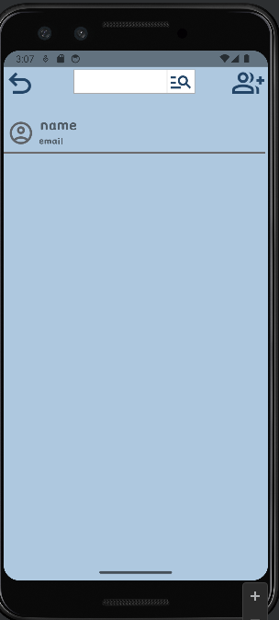

<androidx.constraintlayout.widget.ConstraintLayout xmlns:android="http://schemas.android.com/apk/res/android"
xmlns:app="http://schemas.android.com/apk/res-auto"
xmlns:tools="http://schemas.android.com/tools"
android:id="@+id/main"
android:layout_width="match_parent"
android:layout_height="match_parent"
android:background="#AEC8DF"
tools:context=".activity.Friend">
<ImageButton
android:id="@+id/back"
android:layout_width="50dp"
android:layout_height="50dp"
android:layout_marginEnd="344dp"
android:layout_marginBottom="688dp"
android:background="#00000000"
android:scaleType="fitCenter"
android:src="@drawable/backicon"
app:layout_constraintBottom_toBottomOf="parent"
app:layout_constraintEnd_toEndOf="parent"
app:layout_constraintTop_toTopOf="parent"
app:layout_constraintVertical_bias="0.0"
app:tint="#234567" />
<EditText
android:id="@+id/searchText"
android:layout_width="144dp"
android:layout_height="36dp"
android:layout_marginTop="4dp"
android:fontFamily="@font/font_layout"
android:background="@drawable/border"
android:textColor="#000000"
app:layout_constraintEnd_toEndOf="parent"
app:layout_constraintHorizontal_bias="0.416"
app:layout_constraintStart_toStartOf="parent"
app:layout_constraintTop_toTopOf="parent" />
<ImageButton
android:id="@+id/search"
android:layout_width="42dp"
android:layout_height="36dp"
android:layout_marginTop="4dp"
android:background="@drawable/border"
android:scaleType="fitCenter"
android:src="@drawable/search"
app:layout_constraintEnd_toEndOf="parent"
app:layout_constraintHorizontal_bias="0.691"
app:layout_constraintStart_toStartOf="parent"
app:layout_constraintTop_toTopOf="parent"
app:tint="#234567" />
<ImageButton
android:id="@+id/add"
android:layout_width="50dp"
android:layout_height="48dp"
android:layout_marginEnd="4dp"
android:background="#00000000"
android:scaleType="fitCenter"
android:src="@drawable/friendadd"
app:layout_constraintBottom_toBottomOf="parent"
app:layout_constraintEnd_toEndOf="parent"
app:layout_constraintTop_toTopOf="parent"
app:layout_constraintVertical_bias="0.0"
app:tint="#234567" />
<ImageView
android:layout_width="46dp"
android:layout_height="40dp"
android:layout_marginEnd="344dp"
android:src="@drawable/profile"
app:layout_constraintBottom_toBottomOf="parent"
app:layout_constraintEnd_toEndOf="parent"
app:layout_constraintTop_toTopOf="parent"
app:layout_constraintVertical_bias="0.112" />
<View
android:layout_width="match_parent"
android:layout_height="2dp"
android:layout_centerInParent="true"
android:layout_marginEnd="4dp"
android:background="#676464"
app:layout_constraintBottom_toBottomOf="parent"
app:layout_constraintEnd_toEndOf="parent"
app:layout_constraintTop_toTopOf="parent"
app:layout_constraintVertical_bias="0.172" />
<androidx.recyclerview.widget.RecyclerView
android:id="@+id/friendList"
android:layout_width="match_parent"
android:layout_height="540dp"
android:gravity="center"
android:padding="17dp"
app:layoutManager="androidx.recyclerview.widget.GridLayoutManager"
app:layout_constraintBottom_toBottomOf="parent"
app:layout_constraintEnd_toEndOf="parent"
app:layout_constraintTop_toTopOf="parent"
app:layout_constraintVertical_bias="0.805"
app:spanCount="1" />
<TextView
android:id="@+id/name"
android:layout_width="139dp"
android:layout_height="21dp"
android:layout_marginEnd="204dp"
android:fontFamily="@font/font_layout"
android:text="name"
android:textSize="15sp"
app:layout_constraintBottom_toBottomOf="parent"
app:layout_constraintEnd_toEndOf="parent"
app:layout_constraintTop_toTopOf="parent"
app:layout_constraintVertical_bias="0.109" />
<TextView
android:id="@+id/email"
android:layout_width="206dp"
android:layout_height="23dp"
android:layout_marginEnd="136dp"
android:fontFamily="@font/font_layout"
android:text="email"
android:textSize="13sp"
app:layout_constraintBottom_toBottomOf="parent"
app:layout_constraintEnd_toEndOf="parent"
app:layout_constraintTop_toTopOf="parent"
app:layout_constraintVertical_bias="0.146" />
</androidx.constraintlayout.widget.ConstraintLayout>
<activity_gallery.xml>

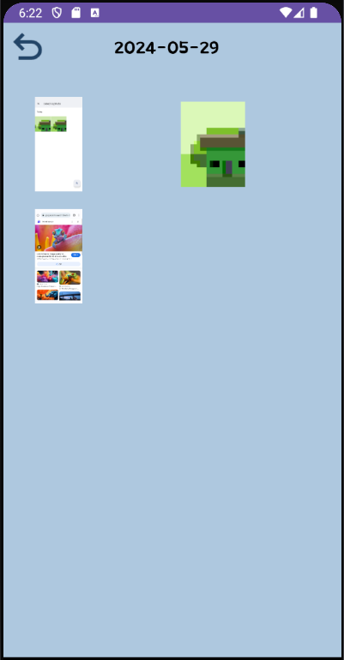
<androidx.constraintlayout.widget.ConstraintLayout xmlns:android="http://schemas.android.com/apk/res/android"
xmlns:app="http://schemas.android.com/apk/res-auto"
xmlns:tools="http://schemas.android.com/tools"
android:id="@+id/main"
android:background="#AEC8DF"
android:layout_width="match_parent"
android:layout_height="match_parent"
tools:context=".activity.Gallery">
<ImageButton
android:id="@+id/back"
android:layout_width="50dp"
android:layout_height="50dp"
android:background="#00000000"
android:scaleType="fitCenter"
android:src="@drawable/backicon"
app:layout_constraintBottom_toBottomOf="parent"
app:layout_constraintEnd_toEndOf="parent"
app:layout_constraintHorizontal_bias="0.01"
app:layout_constraintStart_toStartOf="parent"
app:layout_constraintTop_toTopOf="parent"
app:layout_constraintVertical_bias="0.005"
app:tint="#234567"/>
<androidx.recyclerview.widget.RecyclerView
android:id="@+id/photoList"
android:layout_width="match_parent"
android:layout_height="624dp"
tools:layout_editor_absoluteX="0dp"
tools:layout_editor_absoluteY="50dp"
android:gravity="center"
android:padding="17dp"
app:layoutManager="androidx.recyclerview.widget.GridLayoutManager"
app:spanCount="2"
app:layout_constraintTop_toTopOf="parent"
app:layout_constraintBottom_toBottomOf="parent"
app:layout_constraintEnd_toEndOf="parent"
app:layout_constraintVertical_bias="0.52" />
<TextView
android:id="@+id/date"
android:layout_width="135dp"
android:layout_height="30dp"
android:fontFamily="@font/font_layout"
android:scaleType="fitCenter"
android:text="2000-00-00"
android:textSize="20sp"
android:textColor="#000000"
app:layout_constraintBottom_toBottomOf="parent"
app:layout_constraintEnd_toEndOf="parent"
app:layout_constraintHorizontal_bias="0.5"
app:layout_constraintStart_toStartOf="parent"
app:layout_constraintTop_toTopOf="parent"
app:layout_constraintVertical_bias="0.02" />
</androidx.constraintlayout.widget.ConstraintLayout>
<item_friend.xml>
<LinearLayout xmlns:android="http://schemas.android.com/apk/res/android"
android:layout_width="match_parent"
android:layout_height="wrap_content"
android:orientation="horizontal"
android:padding="16dp">
<ImageView
android:layout_width="46dp"
android:layout_height="40dp"
android:src="@drawable/profile" />
<TextView
android:id="@+id/name"
android:layout_width="242dp"
android:layout_height="35dp"
android:layout_marginTop="5dp"
android:layout_weight="1"
android:gravity="center"
android:fontFamily="@font/font_layout"
android:text="name"
android:textColor="#000"
android:textSize="17sp" />
<ImageButton
android:id="@+id/delete"
android:layout_width="2dp"
android:layout_height="9dp"
android:scaleType="fitCenter"
android:layout_marginLeft="15dp"
android:layout_marginTop="20dp"
android:background="#00000000"
android:src="@drawable/remove"
android:tint="#FF0000" />
</LinearLayout>
<item_event.xml>
<LinearLayout xmlns:android="http://schemas.android.com/apk/res/android"
android:layout_width="match_parent"
android:layout_height="wrap_content"
android:orientation="vertical"
android:padding="16dp">
<TextView
android:id="@+id/date"
android:layout_width="150dp"
android:layout_height="50dp"
android:text="date"
android:gravity="center"
android:textSize="23sp"
android:textColor="#000"
android:fontFamily="@font/font_layout"/>
<ImageView
android:layout_width="150dp"
android:layout_height="100dp"
android:src="@drawable/cover" />
<TextView
android:id="@+id/title"
android:layout_width="150dp"
android:layout_height="50dp"
android:text="title"
android:gravity="center"
android:textSize="23sp"
android:textColor="#000"
android:fontFamily="@font/font_layout"/>
</LinearLayout>
<activity_photo.xml>
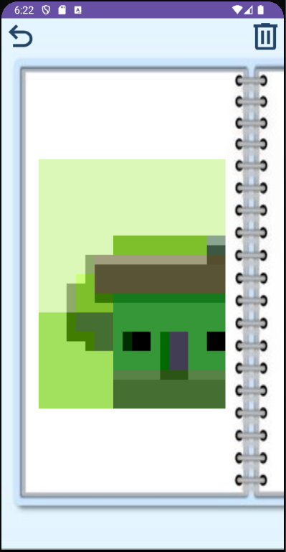

<androidx.constraintlayout.widget.ConstraintLayout xmlns:android="http://schemas.android.com/apk/res/android"
xmlns:app="http://schemas.android.com/apk/res-auto"
xmlns:tools="http://schemas.android.com/tools"
android:id="@+id/main"
android:layout_width="match_parent"
android:layout_height="match_parent"
android:background="@drawable/post2"
tools:context=".activity.Photo">
<ImageButton
android:id="@+id/back"
android:layout_width="50dp"
android:layout_height="50dp"
android:background="#00000000"
android:scaleType="fitCenter"
android:src="@drawable/backicon"
app:layout_constraintBottom_toBottomOf="parent"
app:layout_constraintEnd_toEndOf="parent"
app:layout_constraintHorizontal_bias="0.005"
app:layout_constraintStart_toStartOf="parent"
app:layout_constraintTop_toTopOf="parent"
app:layout_constraintVertical_bias="0.0"
app:tint="#234567"/>
<ImageButton
android:id="@+id/delete"
android:layout_width="50dp"
android:layout_height="50dp"
android:background="#00000000"
android:scaleType="fitCenter"
android:src="@drawable/deleteicon"
app:layout_constraintBottom_toBottomOf="parent"
app:layout_constraintEnd_toEndOf="parent"
app:layout_constraintHorizontal_bias="1.0"
app:layout_constraintStart_toStartOf="parent"
app:layout_constraintTop_toTopOf="parent"
app:layout_constraintVertical_bias="0.0"
app:tint="#234567"/>
<androidx.viewpager2.widget.ViewPager2
android:id="@+id/viewPager"
android:layout_width="260dp"
android:layout_height="560dp"
app:layout_constraintBottom_toBottomOf="parent"
app:layout_constraintEnd_toStartOf="@+id/delete"
app:layout_constraintHorizontal_bias="0.0"
app:layout_constraintStart_toEndOf="@+id/back"
app:layout_constraintTop_toTopOf="parent"
app:layout_constraintVertical_bias="0.497" />
</androidx.constraintlayout.widget.ConstraintLayout>
<item_member.xml>
<LinearLayout xmlns:android="http://schemas.android.com/apk/res/android"
android:layout_width="match_parent"
android:layout_height="wrap_content"
android:orientation="horizontal"
android:padding="16dp">
<ImageView
android:layout_width="46dp"
android:layout_height="40dp"
android:src="@drawable/profile" />
<TextView
android:id="@+id/name"
android:layout_width="3dp"
android:layout_height="40dp"
android:layout_marginTop="5dp"
android:layout_weight="1"
android:fontFamily="@font/font_layout"
android:gravity="center"
android:text="name"
android:textColor="#000"
android:textSize="17sp" />
</LinearLayout>
<item_photo.xml>
<FrameLayout xmlns:android="http://schemas.android.com/apk/res/android"
android:layout_width="match_parent"
android:layout_height="match_parent">
<ImageView
android:id="@+id/photoItem"
android:layout_width="match_parent"
android:layout_height="match_parent" />
</FrameLayout>
<item_gallery.xml>
<FrameLayout xmlns:android="http://schemas.android.com/apk/res/android"
android:layout_width="wrap_content"
android:layout_height="wrap_content">
<ImageView
android:id="@+id/photoItem"
android:layout_width="95dp"
android:layout_height="130dp"
android:padding="10dp"
android:scaleType="fitCenter" />
</FrameLayout>
<Loading.java>
package hgcq.view.activity;
import android.content.Context;
import android.content.Intent;
import android.graphics.Rect;
import android.media.MediaPlayer;
import android.os.Bundle;
import android.view.MotionEvent;
import android.view.View;
import android.view.inputmethod.InputMethodManager;
import android.widget.EditText;
import android.widget.ImageView;
import android.widget.Toast;
import androidx.appcompat.app.AppCompatActivity;
import com.bumptech.glide.Glide;
import hgcq.config.NetworkClient;
import hgcq.controller.MemberController;
import hgcq.view.R;
import retrofit2.Call;
import retrofit2.Callback;
import retrofit2.Response;
public class Loading extends AppCompatActivity {
private MemberController mc;
private Context context;
private ImageView loading;
private MediaPlayer mediaPlayer;
private boolean isLogin = false;
@Override
protected void onCreate(Bundle savedInstanceState) {
super.onCreate(savedInstanceState);
setContentView(R.layout.activity_loading);
if (getSupportActionBar() != null) {
getSupportActionBar().hide();
} // 액션바 숨김
mc = new MemberController(this);
this.context = this;
loading = findViewById(R.id.loading);
Glide.with(this)
.asGif()
.load(R.drawable.loading)
.into(loading);
Intent login = new Intent(this, Login.class);
Intent main = new Intent(this, Main.class);
mc.islogin(new Callback<Boolean>() { //서버로부터 로그인 여부 확인
@Override
public void onResponse(Call<Boolean> call, Response<Boolean> response) {
if (response.isSuccessful()) {
if (response.body()) {
isLogin = true;
}
}
}
@Override
public void onFailure(Call<Boolean> call, Throwable t) {
Toast.makeText(context, "서버 응답 오류", Toast.LENGTH_SHORT).show();
}
});
loading.setOnClickListener(new View.OnClickListener() {
@Override
public void onClick(View v) {
mediaPlayer.stop(); // 음악 재생 멈춤
if (isLogin) {
startActivity(main);
} else {
Toast.makeText(context, "세션이 종료되었습니다.", Toast.LENGTH_SHORT).show();
startActivity(login);
}
}
});
// MP3 파일 자동 재생
mediaPlayer = MediaPlayer.create(this, R.raw.loading);
mediaPlayer.start(); // 음악 자동 재생
}
@Override
public boolean dispatchTouchEvent(MotionEvent ev) {
if (ev.getAction() == MotionEvent.ACTION_DOWN) {
View v = getCurrentFocus();
if (v instanceof EditText) {
Rect outRect = new Rect();
v.getGlobalVisibleRect(outRect);
if (!outRect.contains((int) ev.getRawX(), (int) ev.getRawY())) {
v.clearFocus();
InputMethodManager imm = (InputMethodManager) getSystemService(Context.INPUT_METHOD_SERVICE);
if (imm != null) {
imm.hideSoftInputFromWindow(v.getWindowToken(), 0);
}
}
}
}
return super.dispatchTouchEvent(ev);// 화면 클릭 시 키보드 숨김
}
}

